Welcome Pack for children and parents with anxiety or ASD needs

Information for Parents
Circusful was founded in in 1985, is a registered charity and offers the most extensive youth circus programme of its kind in the UK. Since our inception we have aimed to be inclusive in every way. In recent years we noticed that a growing number of young people with a diagnosis of ASD or awaiting diagnosis, were enrolled in our classes.

Our trainers requested additional training to best support these young people in their circus
experience. With thanks to funding received from the Halifax Foundation we were able to offer Autism
Awareness training to all of our trainer team and staff. The training highlighted that there was much that we already did very well and further steps which we would like to take. A plan of further reasonable adaptions was created and implemented. We are very proud to have been awarded the Impact Award by Autism NI.

What Support Can We Offer Your Child?
- At the point of enrolment you will be asked if your child has any additional needs. The more information you provide the more personalised our support can be. We try to see all of our students as individuals and are happy to begin support pre- diagnosis. You are best placed to advise on strategies that work or don’t work for your child. We know that these change over time and therefore would like to maintain continuous dialogue with you.

- Before your child’s first class we can send you a map and photographs of the building.

- We are able to arrange an orientation visit on request or to send a brief video.

- All of our classes have a clear structure. It varies a little from class to class but the lead trainer for your child’s class will be able to give you a description before they start.
- We have a visual timetable on the wall in the main space to show which skills and which trainers are involved in the class that day.

- If your child does not already have a communication passport we are happy to complete one with you. This is invaluable in helping our team get to know your child.
- For younger children, pop up tents have been provided as a place dedicated to allowing time and space to manage their emotions. The tents contain some sensory toys to assist with this. Other spaces have been identified for older young people to avail of.

- Please make sure that we have the correct contact number and that you are nearby during the period your child is settling in with us. If they need your reassurance, we are happy to call.

Visual Story — First Visit to Circusful
This Visual Story is a simple guide for any family, to support a child with anxiety or sensory needs coming to Circusful for the first time. We recommend you read through it with your child before they attend.

What should I wear to the class?
We have no uniform or clothing rules at Circusful, but, you should wear clothes and shoes you’re comfortable running around and moving in, plus an extra layer you can take off if you’re warm or put on if you’re cold.

Where is the Class?
The class is at Circusful, a specially built circus venue in the Cathedral Quarter of Belfast. From the outside it looks like this:

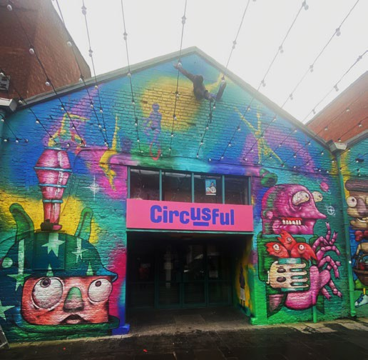
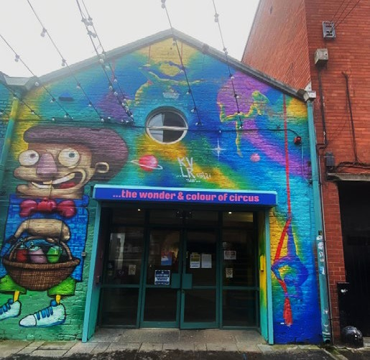

Coming into Circusful
You may have a short wait until the doors of Circusful open to let you and other people in for the class. Our doors look like this:

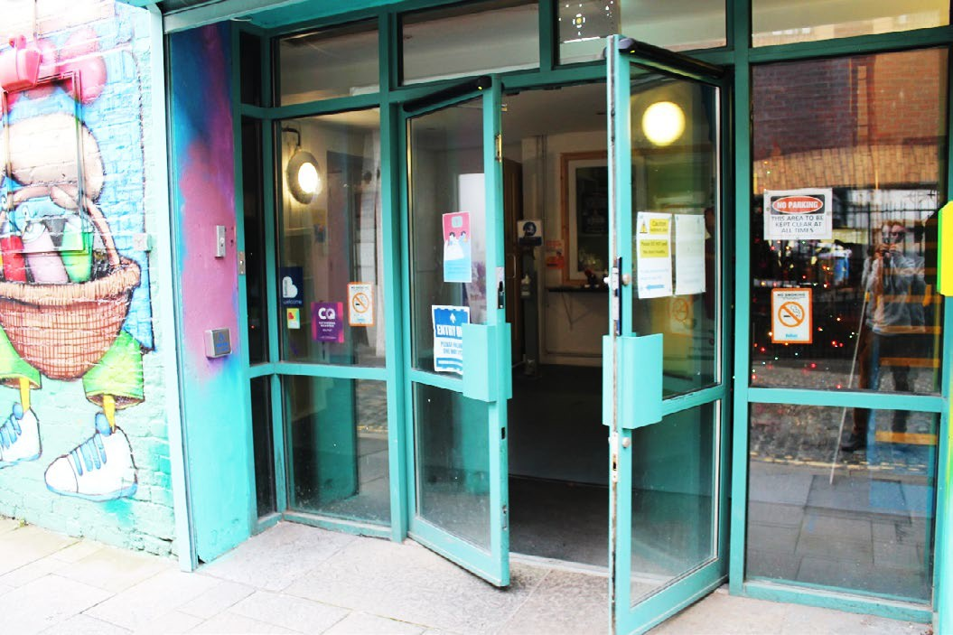

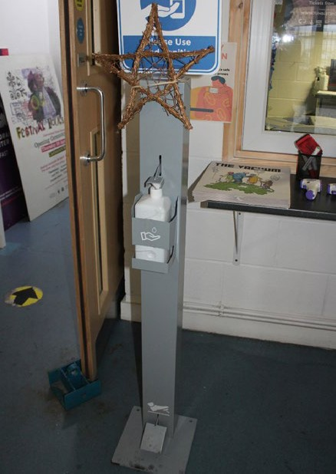
They are automatic doors that open outwards.

In our entrance hall you will be greeted by one of our Circusful trainers. At the back of this pack there is a selection of pictures of our tutors, see if you can find your classes tutors pictures!

You will be asked to sanitise your hands using our sanitising station which looks like this, and has a pedal to operate it:

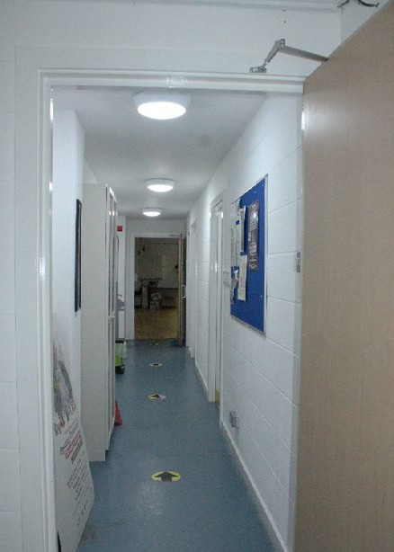
You will then be led down a corridor to the performance space where the class will happen. On this corridor are also the boy’s and girl’s toilets:

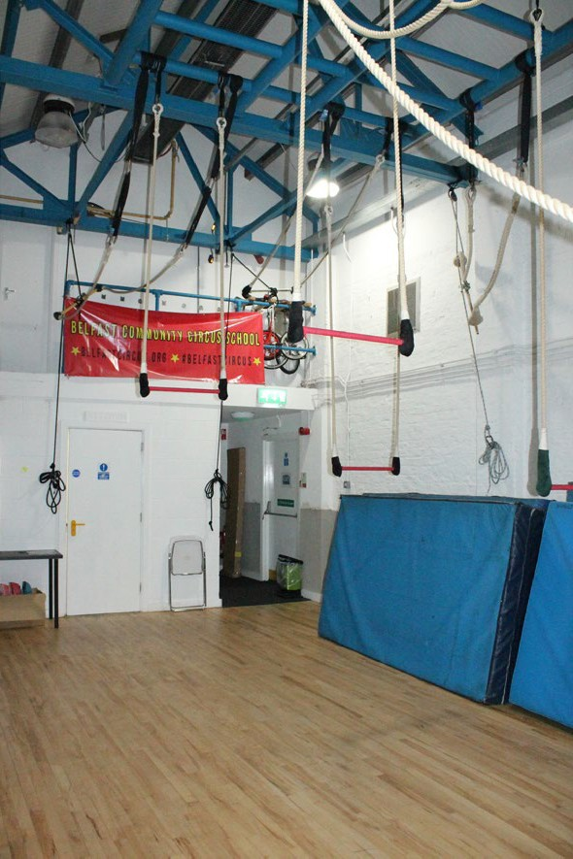
The Spaces at Circusful
You will enter the performance spaces. One is small and has trapezes hanging from the ceiling:

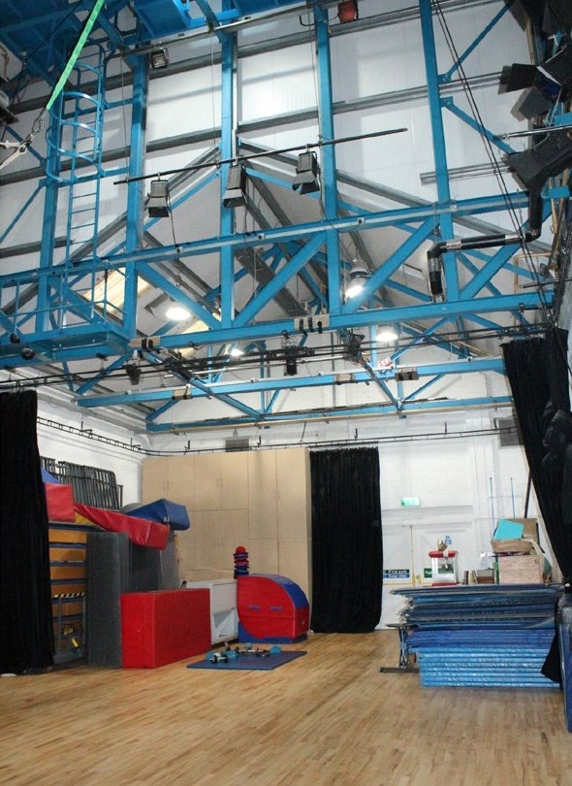
The other space is very large, with a really high ceiling.

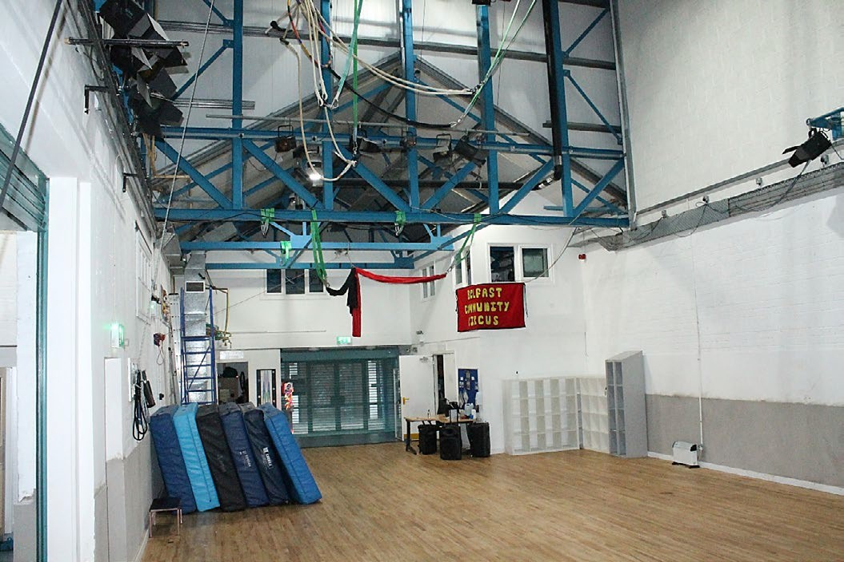

There are cubby holes to place your items in that you wont need when you are doing the class, like a drinks bottle or a coat. You can use any one that is empty:
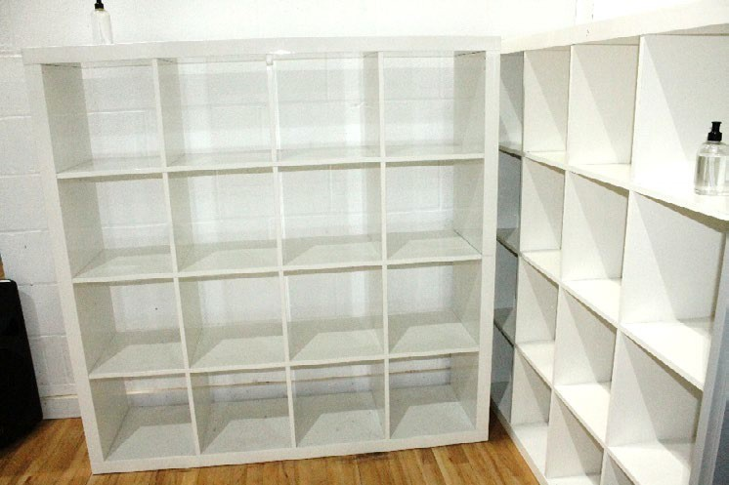
The Circusful trainers will have laid out equipment to use in the class. It’s different each time, but some of the things on the floor may be juggling balls, flower sticks or diablos:

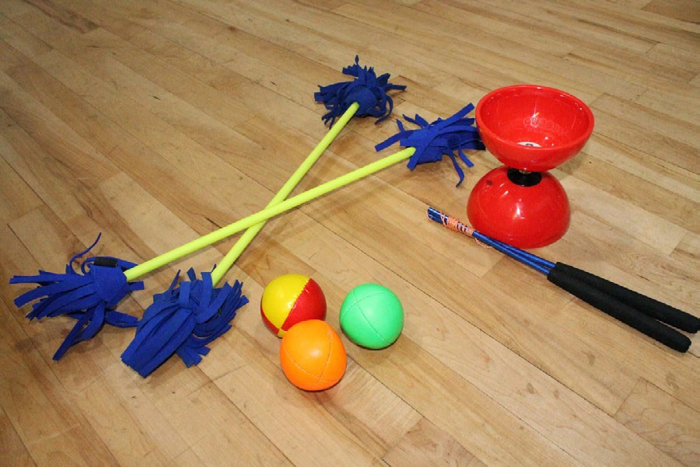

To start the class the Circusful trainers will often ask the group to stand in a circle. This is so that everyone can see each other, say hello and from the trainers what you will be doing. Then it’s all about having fun, learning new skills and working together as a team!
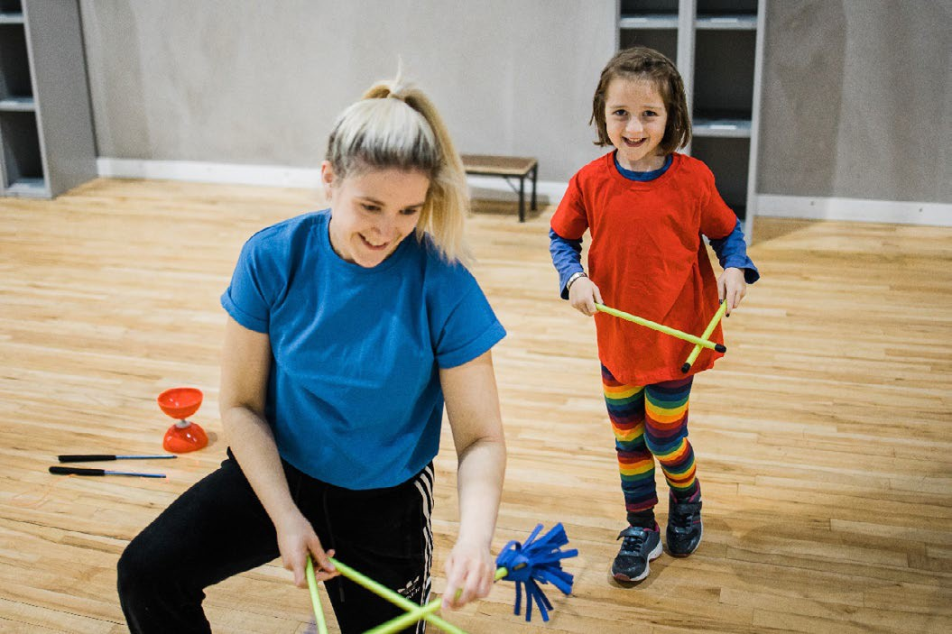

During the class you can visit the toilet at any time, back in the corridor you came in through. Just say to any of the trainers that is where you are going.

With lots of people in the class practising their skills and playing games it can get quite noisy, and busy. If you need some quiet time, we have a mini circus tent where it is quieter, darker and calmer. If you need to use it just say to a trainer “I need to go and have some quiet time” and they’ll help you to do that. You can come back to the class whenever you are ready.

We really look forward to meeting you and for you to begin your journey through the colourful world of circus with us!

For more information please contact:

Ciaran ciaran@wheelworksarts.com 028 9023 6007

www.circusful.org

